|  |  |
| --- | --- |
| **[Assignment / Project] – External Document** |  |
| COMP6176  Human Computer Interaction |
| [~~Odd~~ / Even / ~~Compact~~] Semester Year 2020/2021 |

* Project Title

Caffein Line

* Introduction

Caffein Line is an online café created for people who want to enjoy coffees ,teas and desserts in the comfort of their homes. Currently, we are focusing our delivery area on Indonesia.

* Report / Documentation

1. Home Page

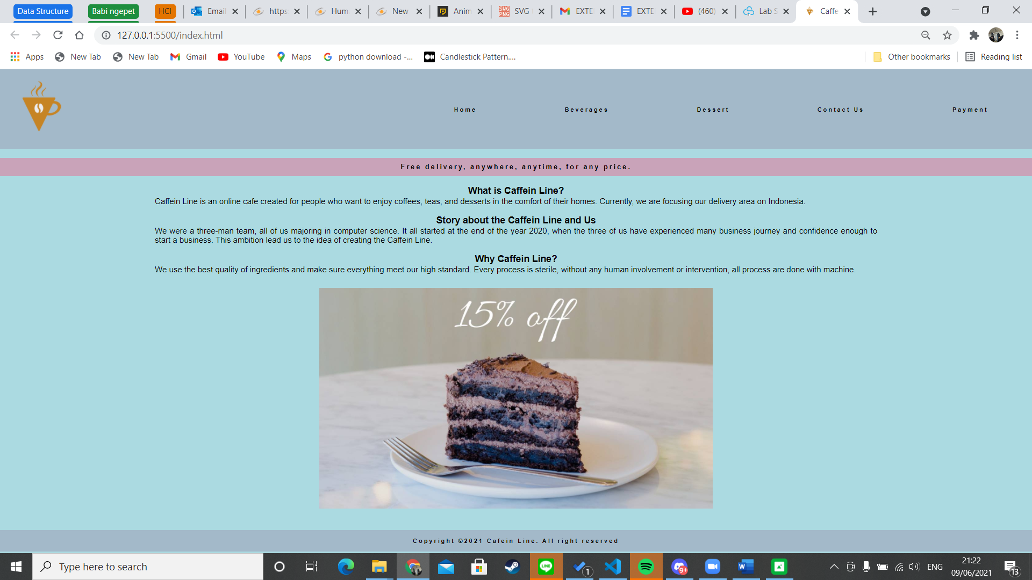

1. Beverages-Coffee

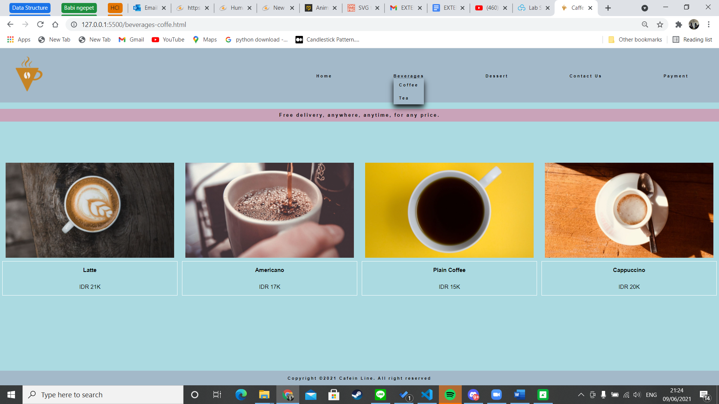

1. Beverages – Tea

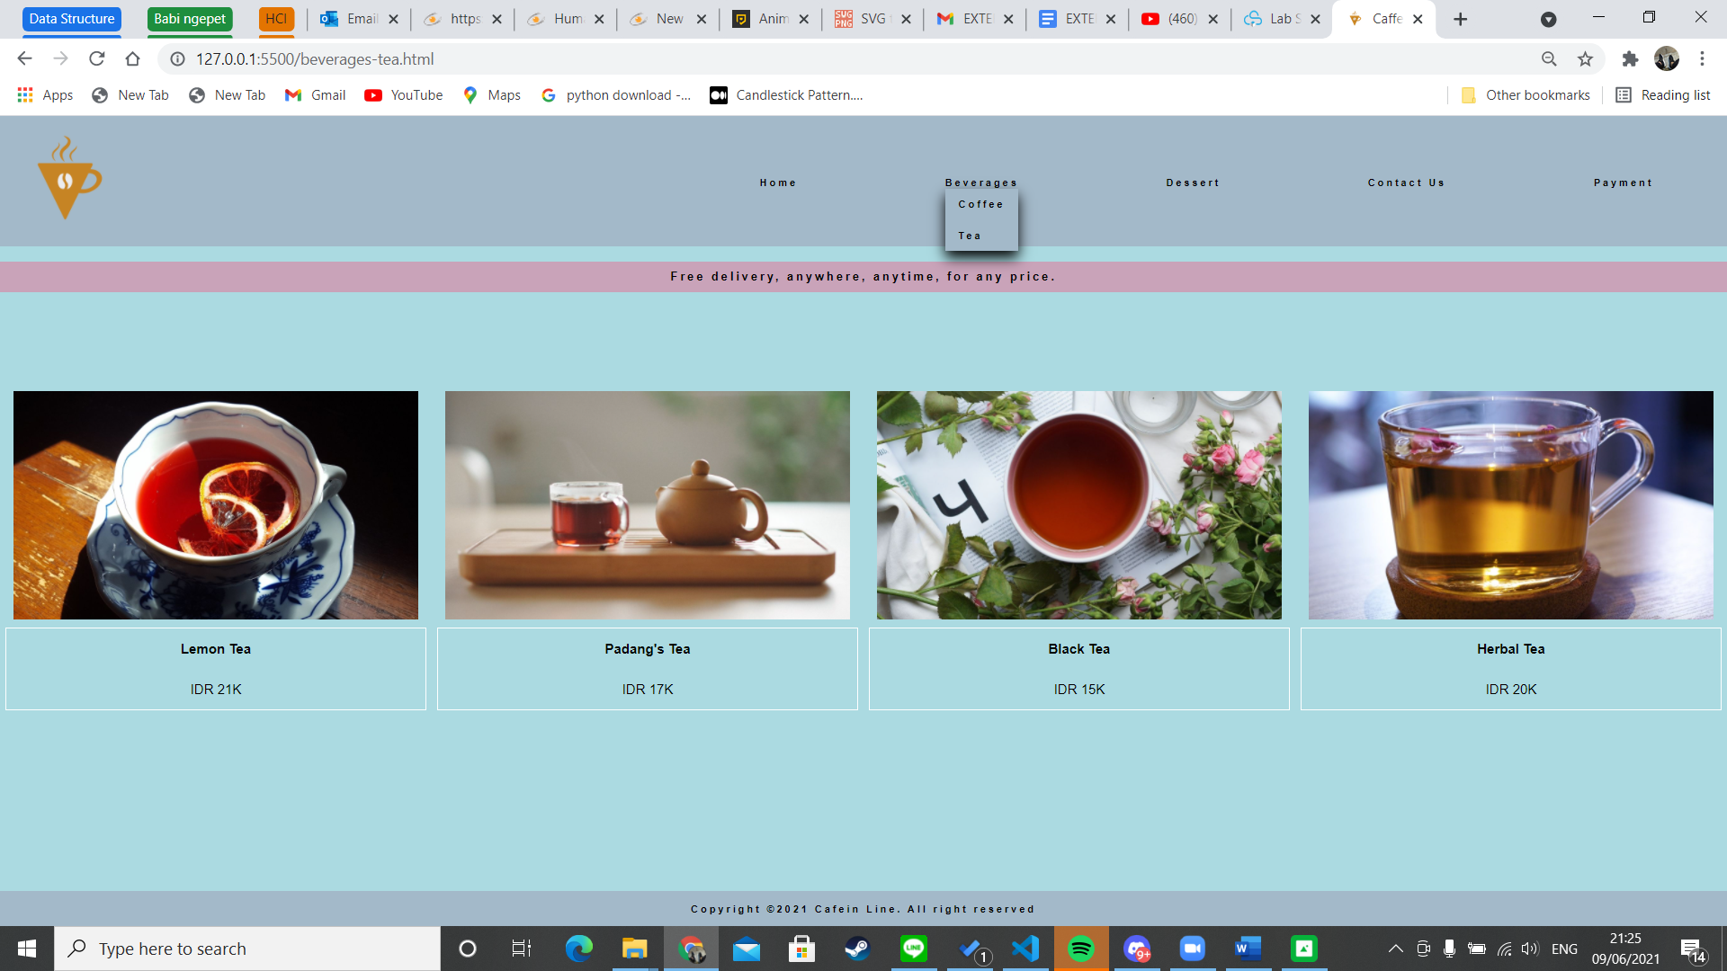

1. Dessert-Coffee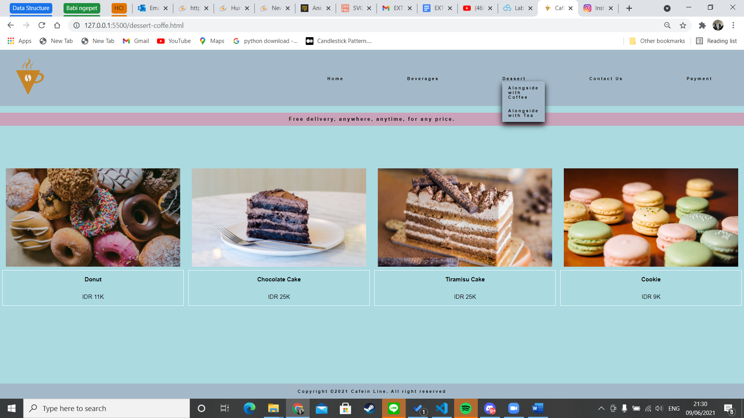
2. Dessert-tea

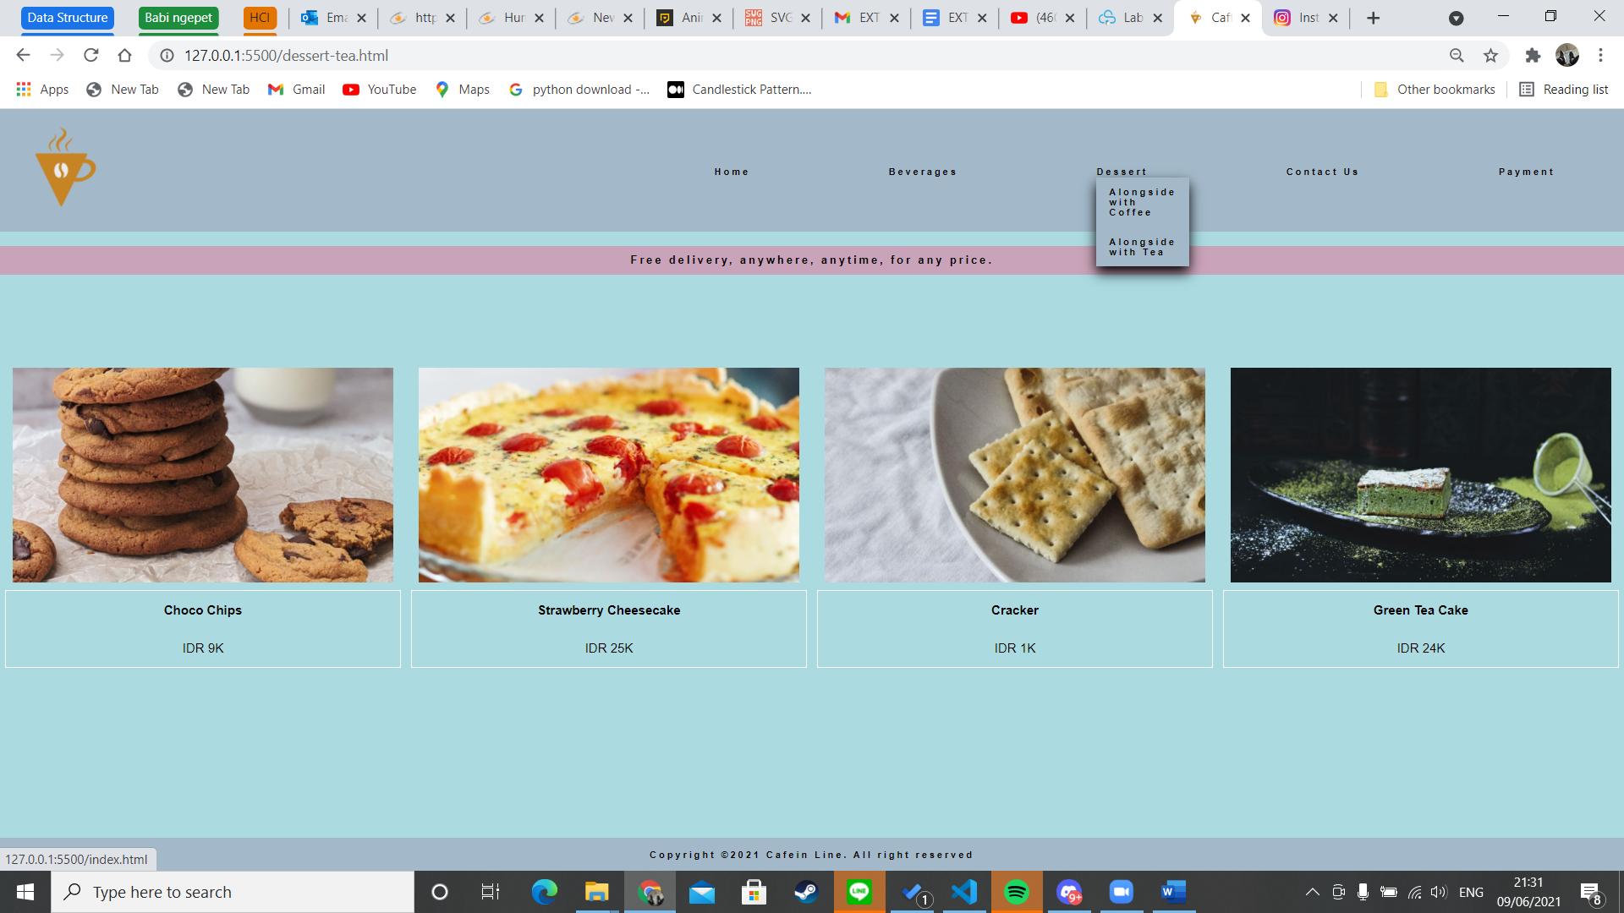

1. Contact us

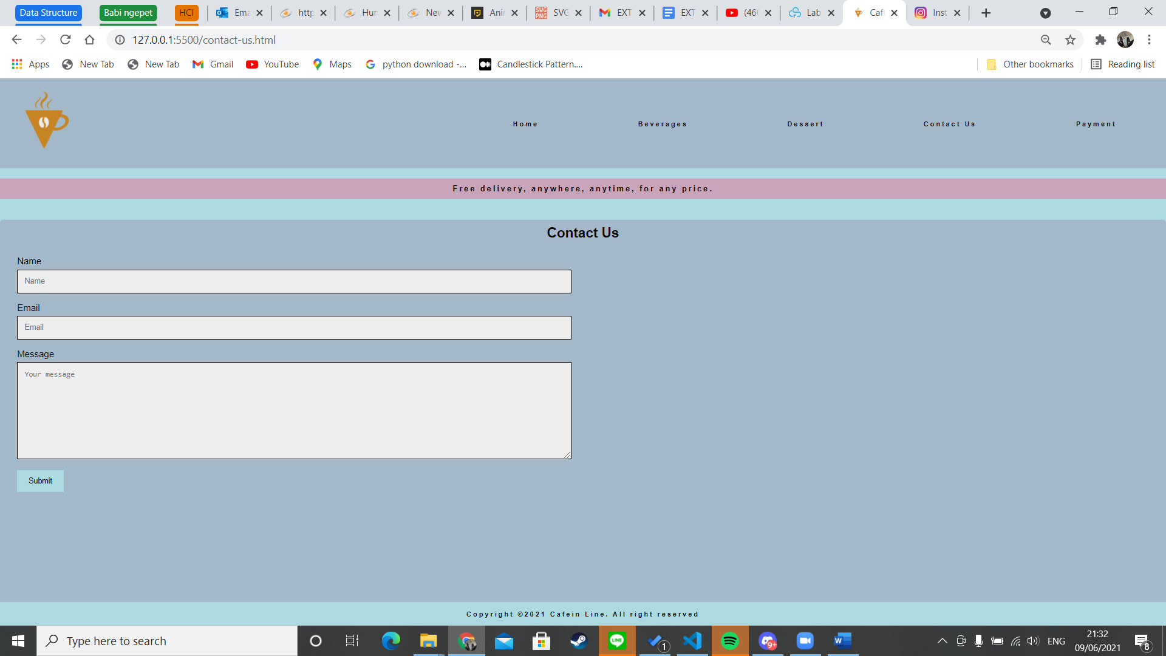

1. Payment

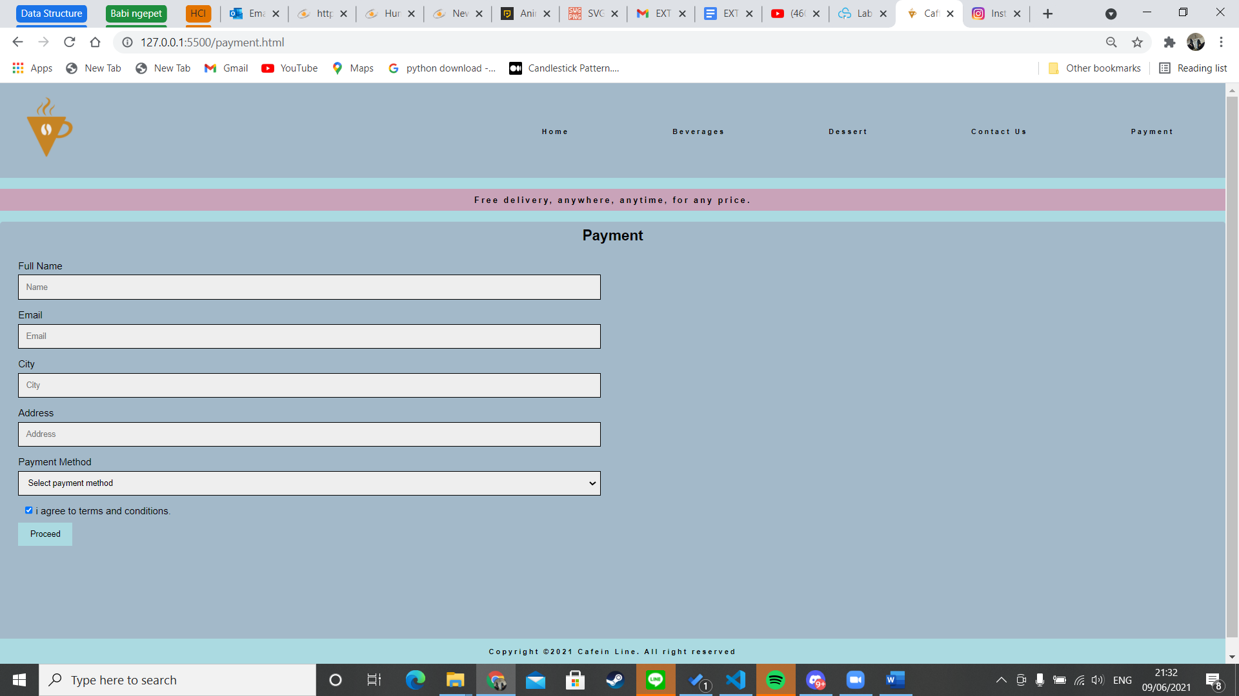

* Reference
* https://www.w3schools.com/
* https://www.tutorialspoint.com/
* Group Member
* 2440016344 - Garry
* 2440016395 – Jason Pratama
* 2440056442– Edward Lokadinata